Prince Andrew High School

Student Council Applications
Monday, May 25th, 2021
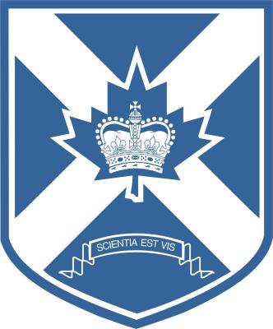 | 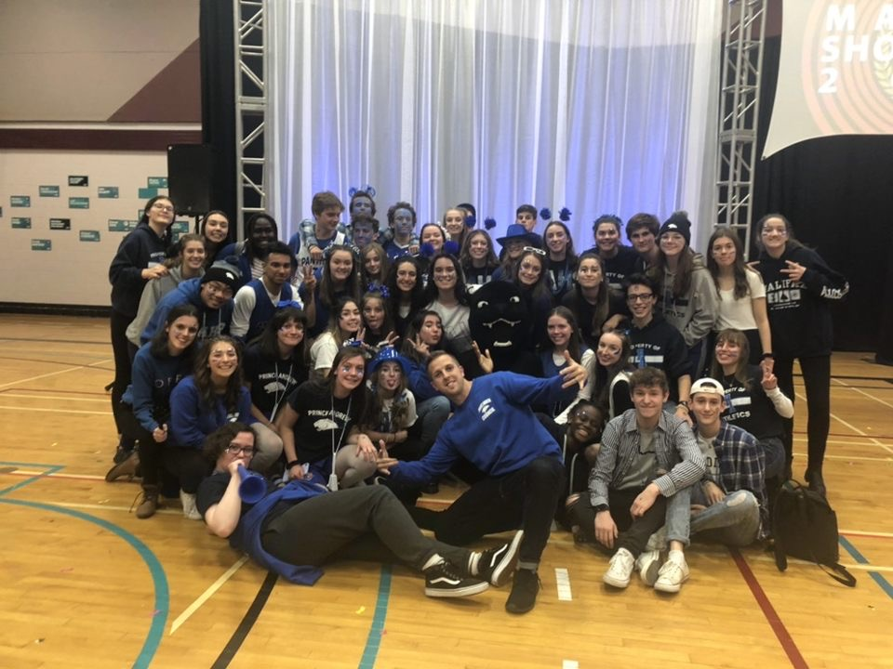

Interested in joining the Student Council at PAHS?
Do you want to contribute to School Spirit, Athletics, Fine Arts, and Community Welfare? Are you interested in having a say about what goes on at PA? If the answer is yes, then Student Council offers an opportunity to meet new people, build leadership skills, and represent the student body.
Below you will find links for; Role Descriptions, Executive Positions, and General Applications. Have a look through the documents and see what fits your style best.

Links
Role Descriptions - Here you will find information about each role.
Executive Application - Recommended for experienced leaders. Council experience is a bonus but not required.
General Council Member Application - Recommended for first-time council members or Grade 9 applicants

*** Applications close Friday, June 4th 2021.

